Title: Retail Sales Data Processing and Business Insights Generation
Company: ABC Retail Solutions
Name: Shashank K R
USN: 1CR22CS175
Branch: Computer Science Engineering College Name: CMR Institute of Technology Submission Date: 2 June 2026

Table of Contents
- Project Overview
- Architecture Diagram
- Data Flow Diagram
- Data Description
- Data Cleaning Strategy
- Transformation Logic
- KPI Summary
- Visual Insights
- Assumptions
- Conclusion

Section 1: Project Overview
ABC Retail Solutions operates across multiple cities through online and offline sales channels. The company collects transactional data from two source systems which contain inconsistencies such as duplicates, missing values, invalid quantities, and inconsistent naming conventions. This project builds an end-to-end data pipeline using Python that ingests, cleans, transforms, and loads retail transaction data into a cleaned dataset. The cleaned data is then visualized using a Power BI dashboard to generate business insights and KPIs.

Section 2: Architecture Diagram

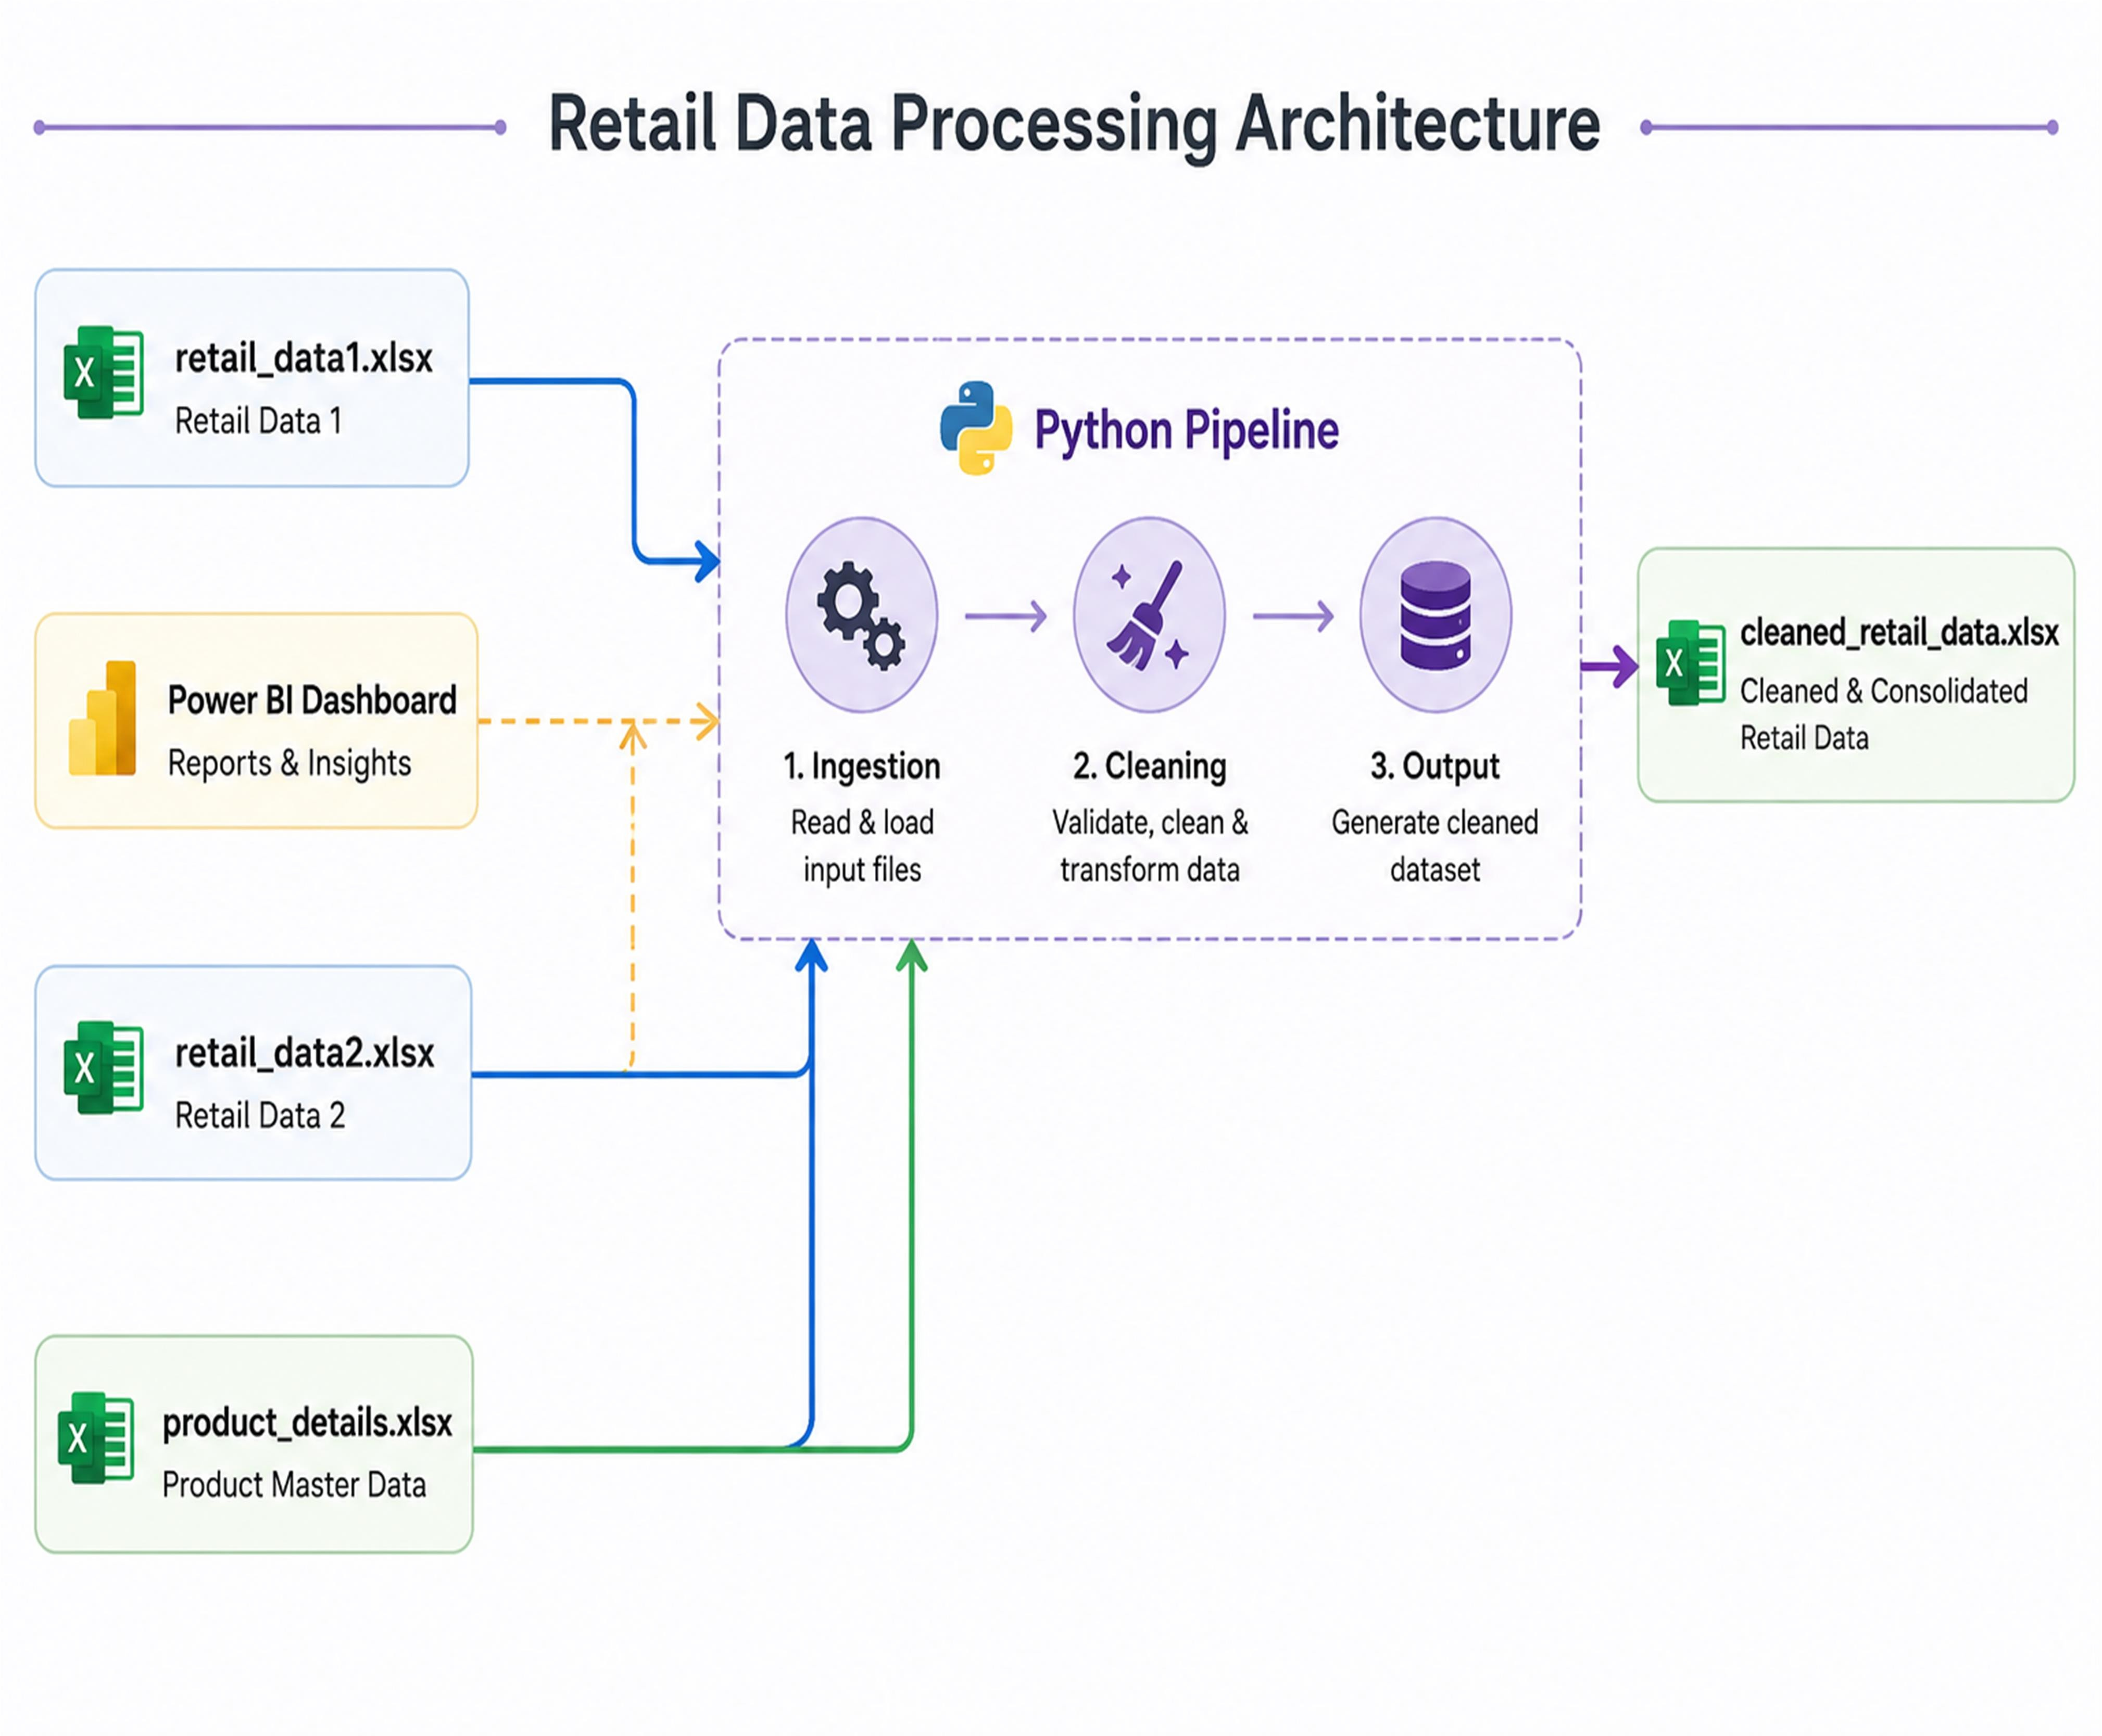

Section 3: Data Flow Diagram
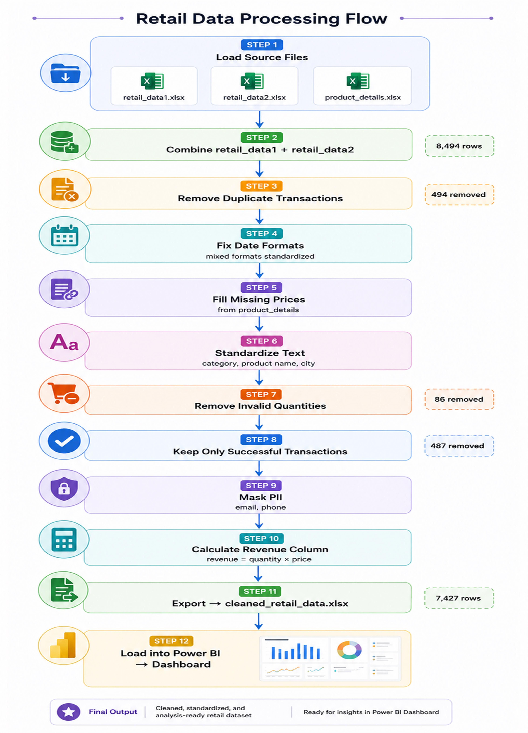

Section 4: Data Description

Dataset | Rows | Columns | Description
retail_data1 | 4,243 | 16 | First transaction source system
retail_data2 | 4,251 | 16 | Second transaction source system
product_details | 10 | 4 | Reference/dimension table
cleaned_retail_data | 7,427 | 21 | Final cleaned dataset

Section 5: Data Cleaning Strategy

Issue Found | Count | Fix Applied
Duplicate transactions | 494 | Removed, kept successful payment record
Missing prices | Several | Filled from product_details using product_id
Invalid quantities (0 or negative) | 86 | Rows dropped
Failed/pending transactions | 487 | Rows dropped
Mixed date formats | Multiple | Converted using pd.to_datetime
Inconsistent category names (ELEC, FURN,  CLOTH) | Multiple | Mapped to standard names
Inconsistent product names (LAPTOP, laptop) | Multiple | Converted to Title Case
PII data (email, phone) | All rows | Email masked, phone hashed

Section 6: Transformation Logic
- REVENUE CALCULATION
Formula: revenue = price × quantity × (1 - discount) Example: ₹70,000 × 2 × (1 - 0.10) = ₹1,26,000

- PII MASKING
Email : First 2 characters shown, rest masked Example: JohnDoe@gmail.com →
Jo****@gmail.com
Phone : Hashed using SHA-256 algorithm Example: 9876543210 → a3f8c2d1e4

- DATE STANDARDIZATION
Mixed formats like 7/21/2025 and 02-19-2026
All converted to standard format: YYYY-MM-DD

- CATEGORY STANDARDIZATION
ELEC / electronics → Electronics FURN / furniture → Furniture CLOTH / clothing → Clothing
HOME / home appliances → Home Appliances

Section 7: KPI Summary

KPI | Value
Total Revenue | ₹1,08,88,54,335
Total Orders | 7,427
Average Order Value | ₹1,46,607
Total Units Sold | 22,125
Top Category | Electronics (₹62.72 Cr)
Top City | Chennai (₹23.28 Cr)
Top Product | Laptop (₹43.18 Cr)
Top Payment Method | Card

Section 8: Visual Insights
- Electronics dominates revenue contributing 57% of total revenue, driven mainly by Laptop sales.

- Chennai leads all cities in revenue followed closely by Delhi and Hyderabad.

- Online and Offline channels are almost equal showing balanced sales across both channels.

- Laptop is the single highest revenue product at
₹43.18 Crores, far ahead of all other products.

- Card and Cash are the most preferred payment methods among customers.

- Revenue peaks during certain months showing clear seasonal trends useful for planning promotions.

Section 9: Assumptions
- Missing prices were filled using the product_details reference table based on product_id.

- Where duplicate transaction_id existed with both successful and failed status, only the successful record was kept.

- Rows with quantity = 0 or negative were considered invalid and removed.

- Only transactions with payment_status = successful were included in revenue calculations.

- Category names were standardized based on the product_details reference table.

- All revenue figures are in Indian Rupees (₹).

Section 10: Conclusion
The end-to-end data pipeline successfully ingested, cleaned, and transformed 8,494 raw retail transactions into 7,427 high-quality records ready for analysis.

Key business insights reveal that Electronics is the top-performing category, Laptop is the bestselling product, and Chennai generates the highest regional revenue.

The Power BI dashboard provides interactive exploration of revenue trends, product performance, category analysis, and regional insights enabling data-driven decision making for ABC Retail Solutions.

